“Channel shift – using data analysis to improve service delivery at the City of Edinburgh Council”

Table of Contents

1 Introduction 3

1.1 Context 3

1.2 Objective of the project 3

1.3 Thesis structure 3

2 Background 4

2.1 User Centred Design 4

2.1.1 Introduction to User Centred Design 4

2.1.2 Human Centred Design 4

2.1.3 Design Driven Innovation 5

2.2 Data-driven design 6

2.2.1 Introduction to big data 6

2.2.2 Business Intelligence 7

2.2.3 Machine learning 7

2.3 Double diamond 7

2.3.1 Discover 8

2.3.2 Define 8

2.3.3 Develop 9

2.3.4 Deliver 9

3 Description of the work undertaken 10

3.1 Discover 10

3.1.1 Meetings at the Council 10

3.1.2 CRM data 12

3.1.3 Mosaic UK Consumer and Demographic Data 13

3.1.4 IBM Cognos 14

3.2 Define 20

3.2.1 Preliminary work 20

3.2.2 Design of the solution 32

3.2.3 Design brief for the next stage 32

3.3 Develop 34

3.3.1 Report 1 - cases of intentional use of multiple channels for the same issue 34

3.3.2 Report 2 - patterns of behaviour across different channels 37

3.3.3 Report 3 - who are the primary users of CEC services 38

3.4 Deliver 47

3.4.1 Presentation at the Council (evaluation) 47

3.5 Problems and conclusions 48

4 Analysis or Evaluation 50

4.1 Evaluation of the tools used 51

4.2 Evaluation of work undertaken 52

4.2.1 Report 1 52

4.2.2 Report 2 52

4.2.3 Report 3 53

4.3 Evaluation of methodology used 53

5 Conclusion 54

6 Appendix A 55

7 Appendix B 58

8 Bibliography 59

# Introduction

Over the last few years, the School of Informatics has been collaborating with the City of Edinburgh Council in the area of open data in initiatives such as the Smart Data Hack and the Council's EdinburghApps hackathons. In the context of Edinburgh Living Lab, this relationship has broadened into investigating other areas of data science, and new kinds of collaboration. My MSc project is taking place within this context, and is focussing on bringing analytic techniques to bear on Customer Relationship Management (CRM) data that has been collected by the Council over the last year.

## Context

As one of the fastest growing local authority areas in Scotland, Edinburgh is facing an ever increasing demand for Council services, outstripping the funds available to meet this demand. There are a number of projects on-going in the Council that try to address the resulting challenges, one of which aims to improve the way that Council interacts with residents, particularly in terms of dealing with complaints and reports of problems. At the moment, citizens can communicate with the Council using multiple 'channels': email, web forms, mobile apps, phone, post and face-to-face conversation. So-called "Channel Shift" is the policy of encouraging residents to use web forms in preference to other communication channels. Some other objectives include informed design of interfaces, improved design of web-forms, increase in use of digital channels and decrease in traditional channels for selected transactions. The Council has been recently building capacity to collect data and use sophisticated tools for managing and integrating it. This project is hoping to contribute to internal resources for extracting business insights from analysing this data. More broadly, I hope that my research will help the Council to ensure that transactions initiated via digital channels are dealt with effectively, as well as contribute to creating “success stories” and know-how within the Council.

## Objective of the project

Using analysis of CRM data provide insights about the delivery of CEC services to the residents of Edinburgh. These insights should serve as guidelines for improvement of existing interactions between the Council and citizens as well as help in implementation of transactions for services which are not supported over digital channels yet.

## Thesis structure

The first part of this thesis is devoted to providing a theoretical background to the work undertaken. User Centred Design is a concept in design that has played a major role in building interfaces to computational systems over the last three decades. It is described providing a historical context and modern developments in related fields. Data-driven design is a practice of designing with the use of data rather than human driven (ethnographical) methods. Double Diamond methodology is a model of practicing design (conducting design related activities) which is claimed to be describing a universal framework for a design process, not related to any particular field.

The second part is describing the work undertaken and is divided into 4 phases in accordance to the Double Diamond model.

The last two parts are dedicated to evaluating the project and drawing conclusions.

# Background

## User Centred Design

### Introduction to User Centred Design

User Centred Design (UCD) is a broad term that describes both a philosophy and a set of tools used during the design process (Norman 2013), (Norman & Draper 1986). At its core, it gives central role to the needs and limitations of the user. The level of involvement of the user in the design process may vary, but the fundamental difference compared to other approaches is that decisions are driven by a very deep understanding of users’ needs (or even by users themselves). It is not limited to interface optimisation and often means working closely with users already at definition stage where they help in the problem identification. Fundamentally, UCD tries to “focus on usability throughout the entire development process and further throughout the system life cycle” (Gulliksen et al. 2003).

The term User Centred Design was coined and popularized by Donald Norman’s research group in the 1980s. Two influential books were published in that time which he co-authored: “User centered system design” (Norman & Draper 1986) and “The psychology of everyday things” (Norman 1988).

User Centred Design is sometimes referred to as User Centred System Design (UCSD). This ambiguity comes from the definition of UCD not being agreed upon for many years (Gulliksen et al. 2003).

Concepts behind UCD did not arise in vacuum. The need for “people oriented computers” was already recognized in the early days of computers (Nickerson 1969), (Ritter et al. 2014). Voices of concern were raised that product development methods used at the time were more suitable for big, labour intensive projects and were failing with sophisticated devices which focus on usability (Robert 1965), (Greenbaum 1993). In 1960s and 1970s there were a number of fields in academia concerned with designing more human friendly devices and processes, but they were applied with varied success. What made UCD so effective was that it “focused on the needs of the user, on activity/task analysis as well as a general requirements analysis, carrying out early testing and evaluation, and designing iteratively.”(Ritter et al. 2014). It also emphasized the involvement of the user in the design process instead of treating him purely a consumer of the product. This has been a paradigm shift that was particularly uncomfortable for managers in the United States who were reluctant to hand over the decision making power (Greenbaum 1993).

UCD has changed over the years. Initially UCD was focused on command-line tools, but as computers got more widespread and their interfaces became more sophisticated, it started growing in importance and played a different role. With Graphical User Interfaces (GUI) it was focused on layouts and optimisation and with nowadays proliferation of computational systems, UCD design is considering things like personal preferences or social and cultural impact of the device (Ritter et al. 2014).

### Human Centred Design

Human Centred Design (HCD) is a broader term that puts humans at the centre (Kurosu 2011), (ISO 1999), (Earthy et al. 2001), (Ritter et al. 2014). This means taking into consideration the entire context of the situation in which the product will be used and the human aspects of it. It is considered more interdisciplinary than UCD and is described in many standards (Bevan 2001) such as ISO 13407:1999 (ISO 1999) and more recently 9241-210: 2010 (DIS 2009). UCD is considered by some as being too much focused on solving a goal-directed, technological problem and limited by considering people solely as users of the system without looking at the organisational goal or counteracting possible adverse effects of use on human health, safety and performance (Bevan 2001), (Gill 1996), (Gasson 2003). UCD and HCD are not synonyms and HCD does not necessarily imply using UCD methods (Ritter et al. 2014), (Kurosu 2011), (Maguire 2001), (Earthy et al. 2001).

### Design Driven Innovation

A recent perspective that is broadening the definition of design to include a reconstructionist (Chan & Mauborgne 2005) or social-constructionist (Prahalad & Ramaswamy 2000) view of the market is Design Driven Innovation (Liem & Sanders 2011), (Verganti 2013).

In his book “Design driven innovation: changing the rules of competition by radically innovating what things mean” Roberto Verganti talks about Design Driven Innovation (Verganti 2013). In his opinion, most organisations understand and use design in two ways: making things beautiful and stylish and having a profound (and thus accurate) understanding of user needs. Innovations coming from these two, beauty of the product and user needs (which is an embodiment of User Centred Design), are in his opinion insufficient for market differentiation and have become so common that they are a norm rather than exception. Verganti argues that what is needed (together with the first two) is a third use for design which is a radical innovation in meaning.

His research reveals that recent management literature focuses on technological innovation and what effect it has on an industry. What is also very well covered is looking beyond features and understanding the meanings behind them - what emotions drive people to buy products. However, the silent assumption is, he continues, that meanings are not a subject of innovation. He proposes a third strategy for design which is innovation in what meaning things can carry.

The author brings and analyses dozens of examples to help better understand design-driven innovation such as:

* Artemide, Italian lamp manufacturer, created a lamp that is no longer a source of light, but an object that has influence on people’s mood. Effectively, by providing a device that can change intensity and colour of the light you are enabling people to control their mood and the product becomes an element of well-being.
* The MP3 players were present before iTunes, but it was a change in how to think about music brought by Steve Jobs that revolutionised the industry. Many executives and lobbing groups stubbornly focused on enforcing copy-protection, whereas Apple enabled users to buy a single song instead of an entire album, taste and mix music, create personal playlists.
* Anthropomorphism in the shape of kitchen appliances brought by Alessi, turned equipment into objects of affection, things you bond with, “teddy bears for adults” (Verganti 2013).
* Apple’s move to release a notebook without an optical drive was considered a bold one, but Steve Job had an understanding of what cloud computing and wireless connectivity meant – constant access to vast amounts of data and thus no use for CDs/DVDs.

The author also provides a structured framework for thinking about innovation in meaning and deploying it in an organisation. Design Driven Innovation extends beyond User Centred Design, but does not discredit it as irrelevant.

## Data-driven design

* What would a cup say if it could speak?
* Amazon poster generated automatically to be personalised
* Web analytics
* NYC analitycs: http://www.nyc.gov/html/analytics/html/initiatives/Initiatives.shtml
* City that runs on data: https://medium.com/@socialmachines/the-incredible-jun-a-town-that-runs-on-social-media-49d3d0d4590
* Data analytics to open data (311 ontology): http://www.semantic-web-journal.net/content/ontology-open-311-data

### Introduction to big data

There are many definitions of what big data is and in some cases not only do they differ, but even stand in contradiction. This might be due to the fact that early cases of use of the term happened in different fields (Ward & Barker 2013) (Demchenko et al. 2014). Most commonly, big data is associated with data storage and data analysis, which in themselves are not new concepts at all. A description that is widely accepted as fundamental in coining the term big data is the “3 Vs” definition provided by Gartner in 2001 (Douglas 2001) (Ward & Barker 2013). Since then, the “Vs” description has been used and expanded (to “5 Vs”) by many (NIST 2015), (Demchenko et al. 2014), (McAfee & Brynjolfsson 2012), (Minelli et al. 2012).

The “5Vs” of big data are as follows:

* Volume – 90% of world’s data was generated over the last 2 years; by some, big data is considered when dealing with volumes over peta bytes (10^15)
* Velocity – more data being received than can be processed using “traditional” data analysis approach; you receive more information than you can process before a decision has to be made; processing of real-time data streams is becoming essential
* Variety – different types of data are being accessible (structured data, sensory data, social media data, voice recordings, photos, videos)
* Veracity (validity) – lack of control over quality and accuracy which leads to inconsistencies and incompleteness
* Value – how to get value out of data

It’s not just about having big data, it’s about finding patterns, getting analysis that will help make the right decision.

### Business Intelligence

#### Introduction to Business Intelligence

#### Business Intelligence and User Centered Design

#### Structured and Unstructured data

(Baars & Kemper 2008)

#### Organisation’s ability to learn (levels of maturity)

### Machine learning

https://www.youtube.com/watch?v=0qOf7SX2CS4

Proliferation of Big Data and AI into other fields, e.g. design.

* DeepMind: https://www.youtube.com/watch?v=EfGD2qveGdQ
* What would be the “optimal” design that we, as humans, cannot see?
* Genetic algorithms:
  + http://brainz.org/15-real-world-applications-genetic-algorithms/
  + http://www.geek.com/science/genetic-algorithms-create-a-better-race-car-555526/

## Double diamond

“Double Diamond” is a model of the design process developed by the UK Design Council (Council 2005), (Council 2007). It is a result of a qualitative study of practices in companies focused on innovation and it describes the commonalities in the creative activities that can be observed among designers regardless of the field they are working in. The model divides the design process into 4 phases as pictured in the diagram below. Each of those phases is focused on a different objective and involves methods which are characteristic to that stage.

[[[[[[[[[[[[[[[[diagram here]]]]]]]]]]]]]]]]] how to reference online images?

http://design.gov.au/doing/projects/business-and-government-interactions-project/lost-in-translation-shared-striving-and-mutual-misunderstanding-in-business-and-government-interactions-findings-report-august-2013/

### Discover

At this stage the attitude adopted is of openness in terms of thoughts and ideas. All ideas are welcome, different perspectives are nurtured and every direction has the potential to be valid. This thinking is typical at the beginning of the project. Designers try to remain as open as possible so that their own perspectives do not limit creativity. This helps in noticing things that might matter, clues about what would make the situation better especially that it might be something unexpected or not identified.

Some of the activities used at this stage include:

* Observation
* User diaries
* Being your users
* Brainstorming
* Choosing a sample
* Quantitative surveys
* Fast visualisation
* Secondary research
* Hopes and fears
* Market research
* User research
* Managing information
* Design research groups

### Define

Second phase is trying to make sense out of all the information collected. It is focused on identifying causalities, narrowing down insights and establishing the main challenge which will be addressed. It takes into consideration limitations of the project in terms of what is feasible given the time and resources. Selection and discarding of ideas takes place here as well. It starts with numerous concepts and ideas and finishes with a clear definition of the problem and a list of actionable tasks.

Activities at this stage often involve:

* Focus groups
* Assessment criteria
* Comparing notes
* Drivers and hurdles
* Customer journey mapping
* Project development
* Project management
* Project sign-off

### Develop

This stage involves intense creation, prototyping and testing. It takes the results of the previous phase as a “design brief” and uses it as a framework for the development process. Iterating is very important in order to improve and refine the prototypes as well as concepts. Attitude of trying and failing ensures the space for testing different implementations using different techniques and thus finding the best one. Some of the tools used are similar to Define stage, but here they are focused on bringing a product ready for production.

Typical to this stage are:

* Character profiles
* Scenarios
* Role-playing
* Service blueprints
* Physical prototyping
* Multi-disciplinary working
* Visual management
* Development methods
* Testing

### Deliver

The last phase is when the product is being finalised, produced and launched. Here it is mass produced, checked before release and delivered to the user. Feedback mechanisms should be in place which will improve the product itself, but also methods and practices used in the process of creation of it.

Characteristic to this phase are the following activities:

* Phasing
* Final testing
* Evaluation
* Feedback loops
* Methods banks
* Approval
* Launch
* Targets

# Description of the work undertaken

## Discover

During the discovery phase of the project the objective was to become familiar with the CEC environment, i.e. find out what tools are available and how they are being used, and gather information about how to best contribute to the organisation. This was to be done while staying as open as possible, allowing any influences or ideas.

At the beginning of the project I had no knowledge about the operations within the Council or which departments would be involved. Some of the questions I wanted to answer included:

* Are there any activities in the Council similar to the scope of the project (or were there any in the past)?
* Who would benefit from it and how to give those stakeholders an opportunity to be involved?
* What questions (in terms of “channel shift”) are not answered in the Council?
* At what level of abstraction should the analysis be conducted?
* What IT systems/tools can be used in the project?
* Who has the necessary understanding of the infrastructure and activities on the architectural level?
* What else do I not know?

### Meetings at the Council

Initially the contact person from the Council was Sally Kerr. In response to my questions she arranged a meeting with a corporate architect Neil Dumbleton. The purpose of the meeting was to give me an opportunity to ask questions regarding organisational structure as well as to get an overview of the context of the project.

As it turned out, it was a first meeting in a series. There was no formalized documentation or central place with knowledge about on-going projects that was made available to the author. As a result, personal meetings were the only way to understand activity in the Council. Moreover, it was only thanks to good will of many employees at the City of Edinburgh Council that this was possible.

The diagram below shows all the people who I interacted with during the entire project. Connections between different actors represent how I got to know them. Circles with coloured backgrounds highlight people who I spoke with in this phase. Orange colour marks people related with University of Edinburgh, blue is for CEC employees. Level of a circle does not reflect a position in the Council’s structure - it is used solely for increasing legibility of the diagram.

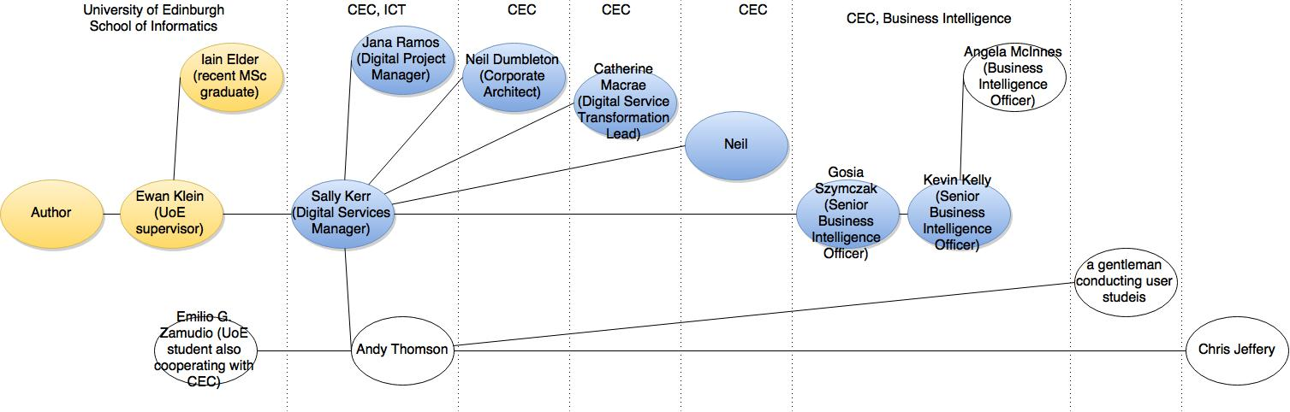

From these meetings and discussions I gained a brief understanding of the situation at CEC. There was a big effort within the Council aiming at transforming the way services are being delivered and “Channel Shift” was a part of it. The outsourced ICT services in the Council were delivered by British Telecom starting from 2001 and the contract was set to end in 2016. In order to find a new service provider under revised conditions, a public tender was being held during the writing of this thesis. It considered “Channel Shift” as one of the significant enhancements of the Council’s operations. Final report suggesting the best bidder was submitted by the Finance and Resources Committee on third of August 2015 (Finance and Resources Committee 2016).

In summer 2014 a new CRM system was introduced called Oracle RightNow. It was replacing the old system called Capture. The deployment was part of the transformation. The system was used to capture information about all interactions with citizens and in some cases it meant that entries did not have all the values specified (due to the nature of an inquiry). The incompleteness of entries did not make them useless as they could still inform about things like level of use. The data captured has not been analysed from the angle described in this project (socio-economic insights) and it was confirmed that such analysis would be useful for the Council.

The transformation within the Council was also trying to centralise Business Intelligence capabilities. The BI department had a number of responsibilities and systems. One of those systems was called IBM Cognos. It was fully operational and a number of reports were generated and delivered to stakeholders. However, the scale of deployment was still unclear and many departments were still figuring out the role the system in their operations. Many services required more digitisation and given the strategy, they could potentially use Cognos in the process. CRM data was an example of a dataset that was promising in providing valuable business insights.

Considering the above, the project would develop a piece of work that would increase know-how within the Council (in terms of using data analysis for designing services and interfaces), provide a “case study” and directly deliver business value to the organisation. The tools and datasets that could be used are described in the following sections.

### CRM data

The new system used at the Council was called RightNow and was provided by Oracle. It was a cloud service and the data in the system was available to CEC employees after registration (with staff number) and installation of the interface. The database consisted of a number of tables, e.g. “Answers” which was a “knowledge base for consultants”. The table used in the project was “Incidents” and it contained information about transactions initiated by citizens (issues reported by them through all channels). The choice was dictated by the scope of the project - de facto by preferences of the clients who were interested in better understanding of the usage patterns of citizens.

UPRN is a number uniquely identifying a household in Edinburgh and thus a person (or a family). Incidents table had a column named UPRN which provided information about who reported the issue. The Mosaic personas were also using UPRN making it possible to link the two datasets.

The table had dozens of columns containing information about things like channel used to report the issue, postcode where it was reported, date reported, Service Level Agreement (SLA).

During creation of an entry, not all columns were required, making it possible to add to the table entries without all fields. There were still many valuable insights possible despite this fact, e.g. number of enquires in different channels. The reason why they were not necessary was to use the CRM system to monitor all activity, even cases of general question to the Council.

### Mosaic UK Consumer and Demographic Data

Mosaic is a dataset created by Experian - credit reference agency. It provides insights about lifestyles and preferences of people across the United Kingdom. It identifies 14 social groups and a total of 57 types within those groups. It was built using more than 450 data variables and the sources include, but are not limited to (Experian 2014):

* Census
* Open Data
* OFCOM Broadband speeds
* Higher Education Statistics Authority (HESA)
* Electoral Roll
* Council Tax property valuations
* YouGov’s survey of consumers and their financial behaviour
* British Crime Survey

It is highly detailed (e.g. food a person buys based on information from retailers) and granular (every household). It can be used as a numerical dataset (Cognos package) or a descriptive interpretation (portal).

Some of the information about a household available in Mosaic includes:

* Age of members
* Income
* Spending structure
* Property type
* Contact channel preference
* Education

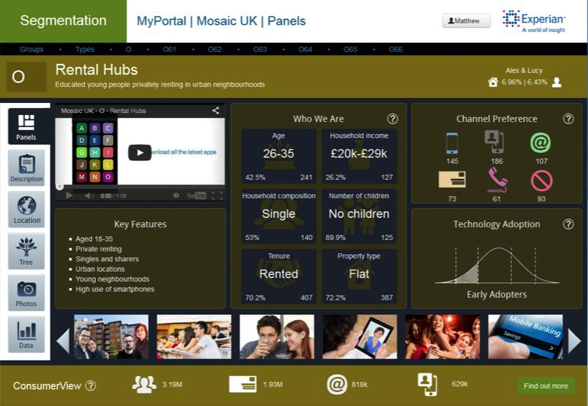

Figure Segmentation portal visualising Mosaic data (Experian 2014)

### IBM Cognos

#### Introduction

Addressing the need of businesses for software helping to achieve a competitive advantage, IBM has a rich portfolio of analytics products. These include solutions in areas of predictive analytics, risk analytics, prescriptive analytics, enterprise performance management and business intelligence (IBM 2015). Majority of IBM products in BI belong to Cognos family and include very specialized applications like “Cognos Supply Chain Performance Procurement Analytics” as well as general purpose tools like “Cognos Business Intelligence”.

The solution used at CEC is IBM Cognos Business Intelligence 10.2.1 and it is a set of tools that significantly eases processes such as importing data from different formats (e.g. csv, xml, xlsx), combining relational and multidimensional data, generating reports (real time reports, drag-and-drop GUI, database queries in SQL and OLAP), scheduling and redistributing reports, publishing reports on multiple platforms and many more. Tools available at the CEC include: Report Studio, Query Studio,

The same results can be achieved using different tools, but some of them are better fitted for a specific purpose. Report Studio was designed with reports creation in mind, Query Studio was optimized for creating and editing complex database queries. CEC has two types of instances of IBM Cognos – production and development machines, accessible under different URLs.

IBM Cognos BI is an enterprise class SOA platform (Browne et al. 2010). Its n-tiered architecture is made up of:

* + The web tier – provides user sessions connectivity to applications
  + The application tier – load balancing and processing of requests, managing storage of customer application data
  + The data tier

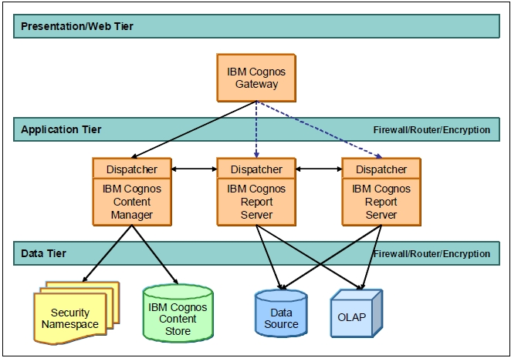

Figure IBM Cognos BI architecture (Browne et al. 2010)

The platform operates by using different services which are run at those three levels (Browne 2010), for example:

* Agent service – responsible for running agents, “determines which tasks to execute and forwards those tasks to the monitor service for execution”
* Monitor service – handles requests which will be run in the background including background tasks, reports scheduled to be run and e-mailed, jobs
* Query service – “manages Dynamic Query Mode requests and returns the results to the requesting batch”

Selected alternatives to IBM Cognos BI:

* Qlik – http://global.qlik.com/uk
* CAFE – cognos analysis for Excel
* Tableu – http://www.tableau.com/

#### Working with IBM Cognos BI

IBM Cognos can be accessed using either a web interface called IBM Cognos Connection or a Windows application. For the purpose of this project only web interface was used.

The URL for accessing IBM Cognos Connection is: http://c-cog-dev-app-1/ibmcognos/

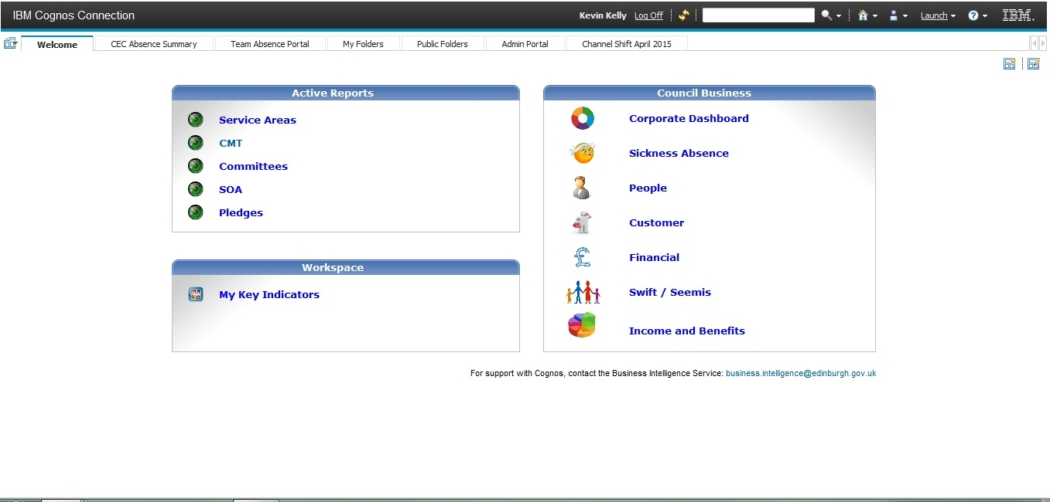

Figure Welcome page of IBM Cognos Connection 10.2.1 (web interface to the entire package)

From this welcome page you can start applications available within your license, e.g. Report Studio. The first step after starting Report Studio is a selection of data package.

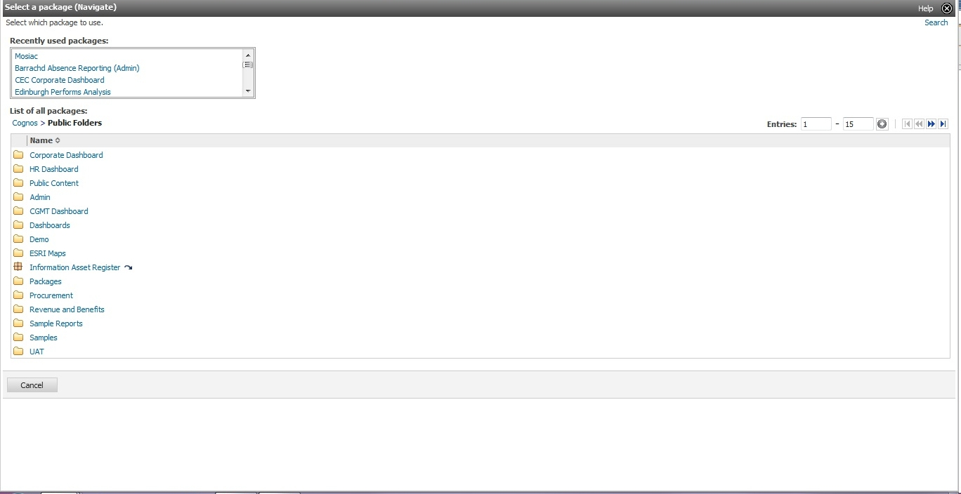

Figure Select data package for Report Studio

After selecting the data package, one can either open an existing report or start creating a new one. In the latter case, a number of templates are available.

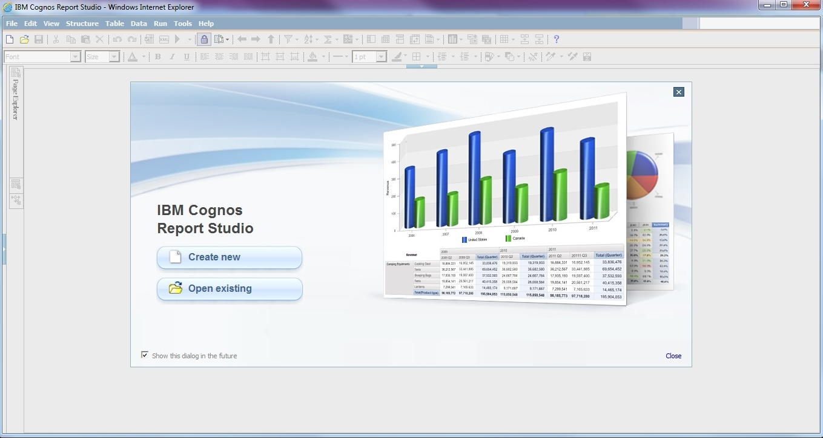

Figure Report Studio welcome page

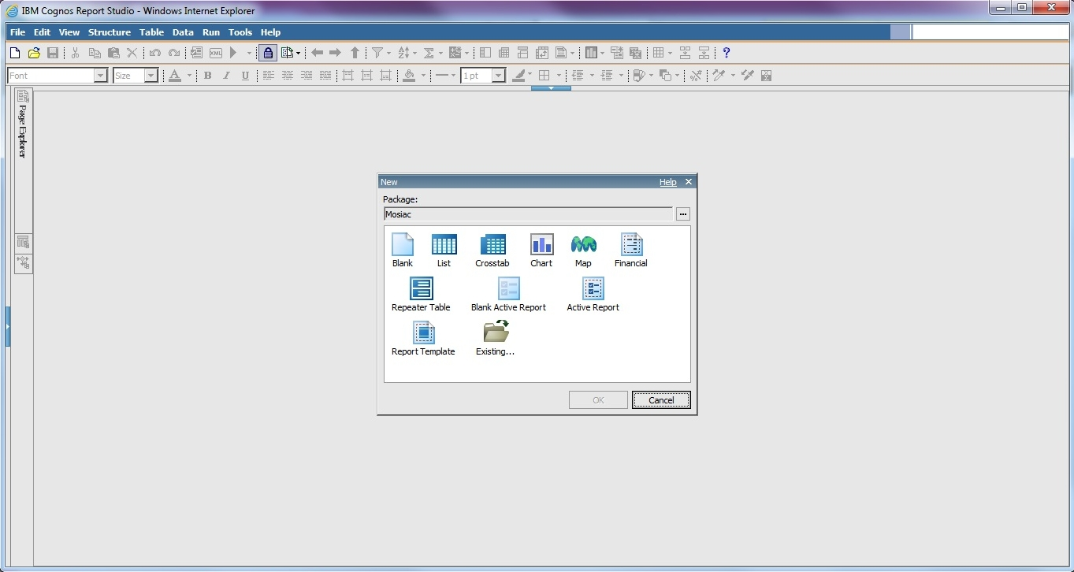

Figure Select a template

The following figure shows Report Studio with a blank report and Mosaic data loaded.

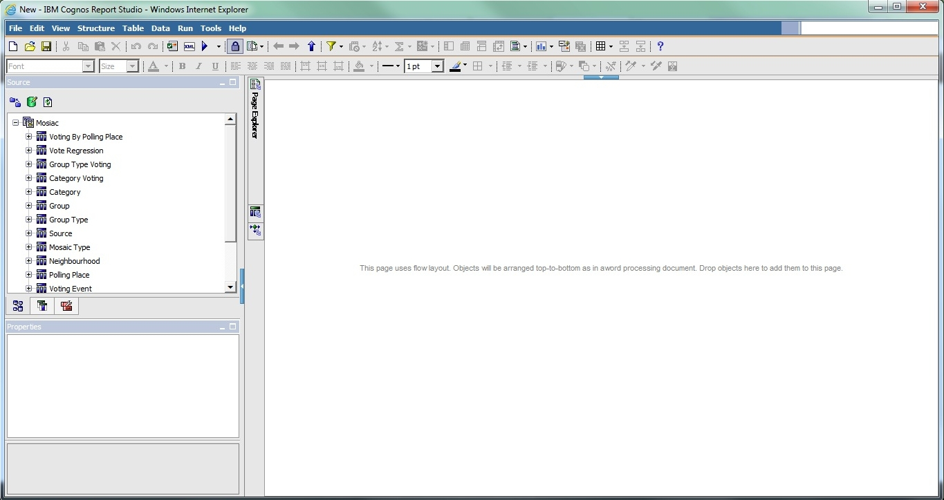

Figure Blank template, Mosaic data loaded

Graphic User Interface (GUI) makes the entire process quick and easy, but it is used to set the general structure of the report. The specifics of the report, e.g. how to filter data, have to implemented using queries.

Example of a single SQL query (filter):

if ([No of interactions with CEC] > 3) then ( 'above 3') else ('up to 3')

Example of a counter:

count(rows for [MW].[MW].[Date Created], [MW].[MW].[UPRN], [MW].[MW].[Subject])

Example of the SQL query used to generate an entire report (the entire report can be exported to an XML format):

select

MW."Creation Source" as Creation_Source,

MW."Group" as Group2,

MW."Date Created" as Date_Created,

MW."Reference #" as Reference__,

MW.Subject as Subject,

MW."Product Hierarchy" as Product_Hierarchy,

MW.UPRN as UPRN,

XCOUNT(MW."Reference #" at MW.UPRN,MW."Reference #" for MW.UPRN ) as No_of_interactions_with_CEC,

D_MosaicGroupType.GroupTypeCode as Group_Type_Code

from

MW...MW MW,

Mosaic.MosaicExport.dbo.D_MosaicGroupType D_MosaicGroupType,

Mosaic.MosaicExport.dbo.F_MosaicAddresses F_MosaicAddresses

where

(MW.UPRN = F_MosaicAddresses.Uprn) and

(D_MosaicGroupType.GroupTypeId = F_MosaicAddresses.MosaicGroupTypeId)

group by

MW."Creation Source",

MW."Group",

MW."Date Created",

MW."Reference #",

MW.Subject,

MW."Product Hierarchy",

MW.UPRN,

D_MosaicGroupType.GroupTypeCode

filter

(XCOUNT(MW."Reference #" at MW.UPRN,MW."Reference #" for MW.UPRN ) > 3)

order by

Date_Created asc

If an item is removed from report it is permanently removed. In most cases, the author of the report does not want it to be completely removed. They just want to remove it from a specific point in the report. In that case, cut function should be used instead.

The number of entries that can be imported from an external data source is limited to 20000. It is not a Council specific limit, it is a limit on the platform itself (IBM n.d.). When a new package is created on top of another, it is not overwritten – a copy is created which contains both data sources.

## Define

After the discovery phase an understanding of the specifics of the project within the Council has been achieved. The goal of the next phase was to narrow down the scope, find specific questions to be answered and make a decision about tools that would be used. Prototypes were created (simple reports) to prove the capabilities of the system. This phase ended with clear objectives and a general idea of technical aspects of implementing them.

### Preliminary work

#### Meetings at the Council

Describe how the users were driving design decisions (e.g. incidents table from CRM)

Meetings with Kevin to have a look at BI platforms, what kind of reports they generate.

The extract used in the process was from May 2015. - the data I'm working on is May extract, only entries with UPRN

5224 registered in 05.2015

24671 in total in 05.2015

The CRM dataset I was working on was limited to May only, entries without UPRN were filtered. There were 979 entries left as a result

* + Gosia Szymczak (Sally introduced me to Gosia)
  + Kevin Kelly (after meeting Gosia, she introduced me to Kevin)
  + Andy Thomson (Sally introduced me to Andy)
  + Angela McInnes (Kevin introduced me to Angela)
  + Emilio G. Zamudio (the other student at CEC, Andy introduced me to the fellow student)
    - Chris Jeffery gave him an extract of data from CRM system
    - He is using IBM SPSS
    - UoE: Finlay Buchanan
    - CEC: Danny Galliker
  + A gentleman conducting user studies (Andy introduced me to him)
  + Chris Jeffery (Andy forwarded an e-mail with my questions to him, he was the person who knew the most about the CRM system, Andy cc-ed me to an e-mail)

#### First iteration (proof-of-concept)

The purpose of this stage was to go through the entire cycle of development. Before discussing what kind of analyses would be useful to the Council I had to confirm that it was possible to use the two datasets together and understand what limitations to the process were. There were no existing reports of this kind so I had to create the Cognos package for CRM and Mosaic data.

The Mosaic package has already been imported to the platform as it was being used in other Business Intelligence reports. The process of importing CRM data was manual, but it is planned to be automated in the future. It is assumed that UPRN uniquely identifies the user.

What I needed to do was to add to the Mosaic package on IBM Cognos an external source of data (CRM dataset) using built-in ETL (Extract, Transform, Load) mechanisms, which required administrative access rights. The platform is quite flexible when it comes to file extensions and data formats. Some of the acceptable extensions include: .csv, .xls, .xlsx, xml. The CRM dataset was extracted from the Council’s system and saved as an .xlsx file on a shared network drive. I then created the package and generated a few simple reports as described below.

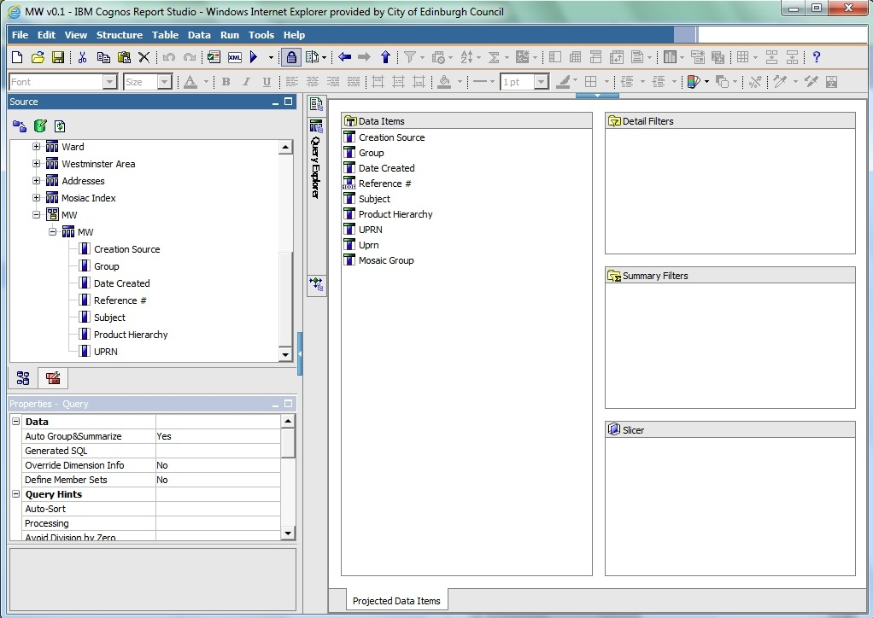

Figure Creating query

The above diagram shows the package containing Mosaic and CRM datasets loaded in Cognos. A simple query is then used to show the content of it to verify that it is working as expect - CRM entries are linked with Mosaic entries using UPRN. The results of the query are visualised on the diagram below.

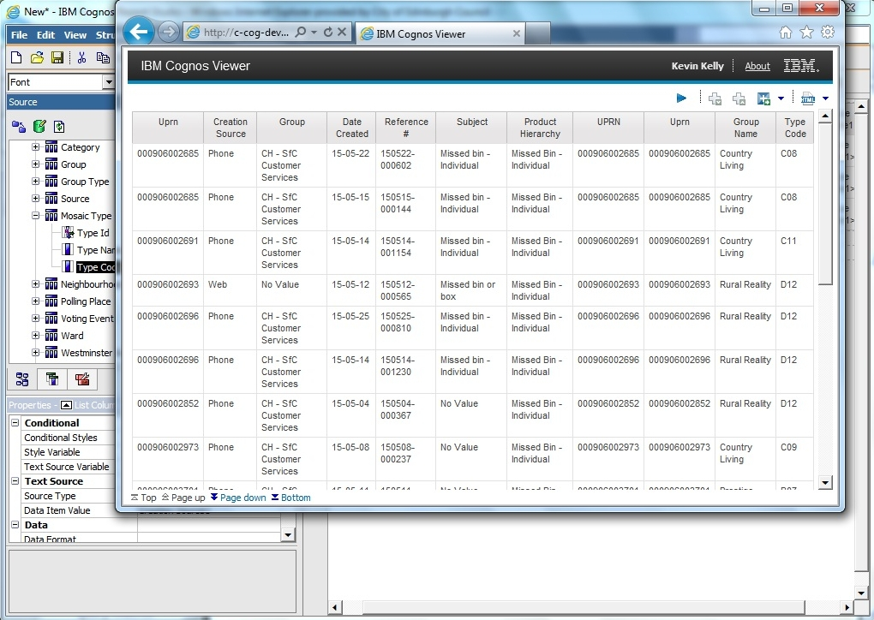

Figure 9 First report - no analysis, plain CRM data

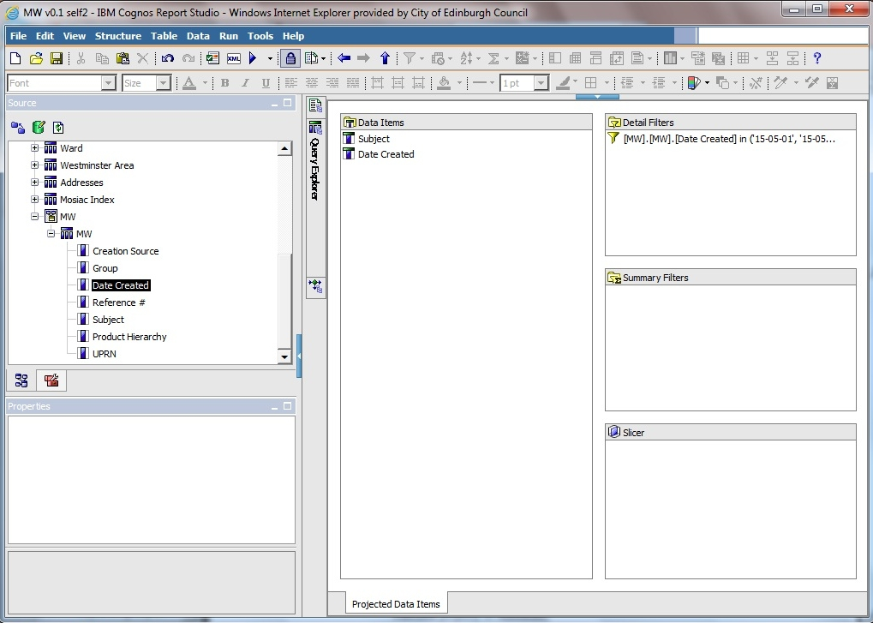

Figure second query

The above screen shot is showing another query which was filtering entries based on the date of creations.

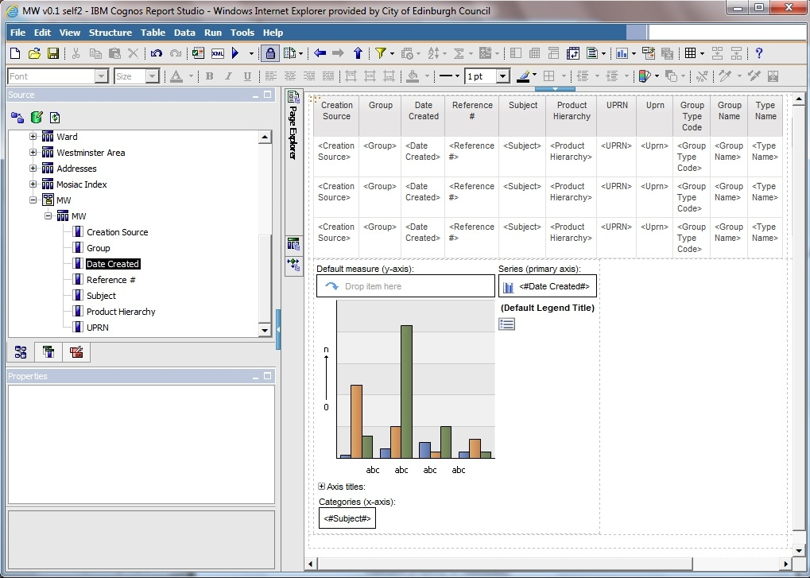

Figure page layout

In the next one, chart is created and here you can see how the layout of the report can be controlled – at the top of the page a list is added followed by a chart.

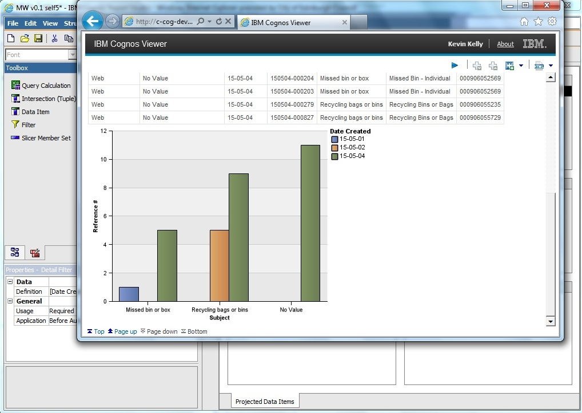

Figure first chart

In this case, the chart was based on the data from the list. This was in order to manually verify that the chart generation happens as expected. Below is the second part of the dataset and the filter used.

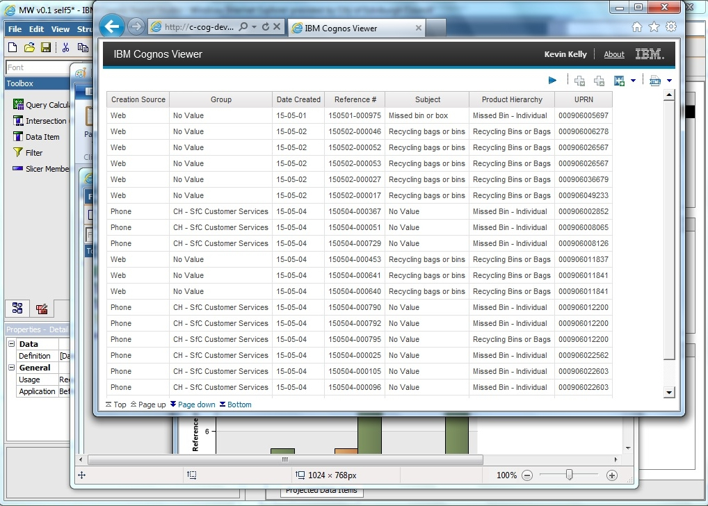

Figure first chart - data to confirm chart is valid

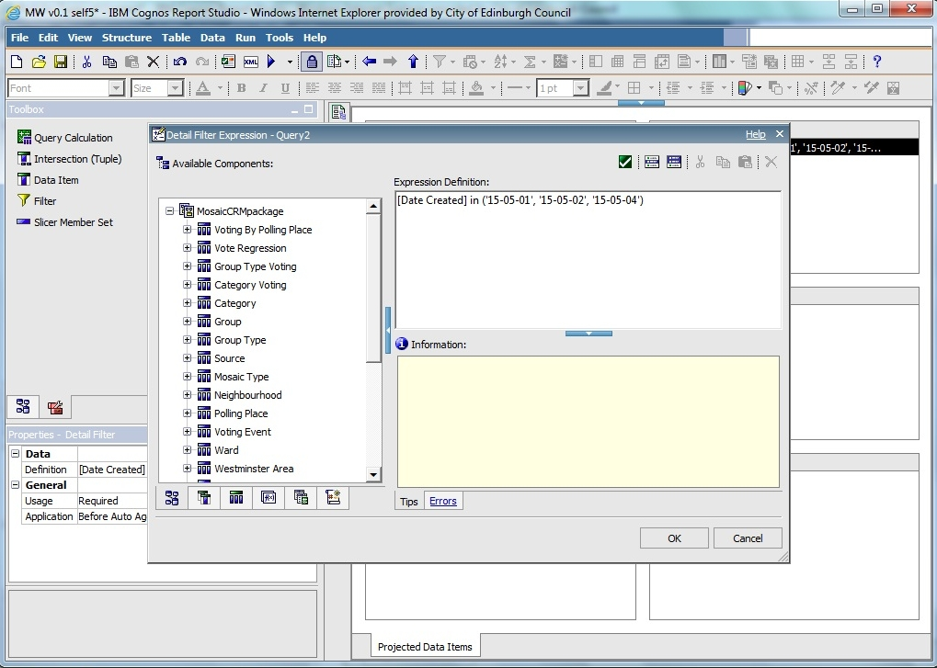

Figure 14 first chart - date filter

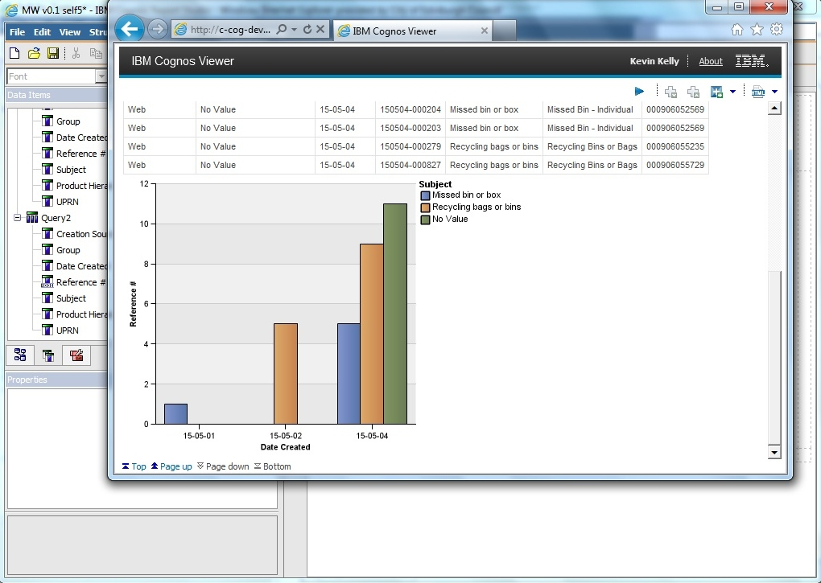

Figure 15 first chart - other dimension

This diagram shows exactly the same dataset, but a different dimension is used for axis x and data series.

Below are a few more examples of reports generated.

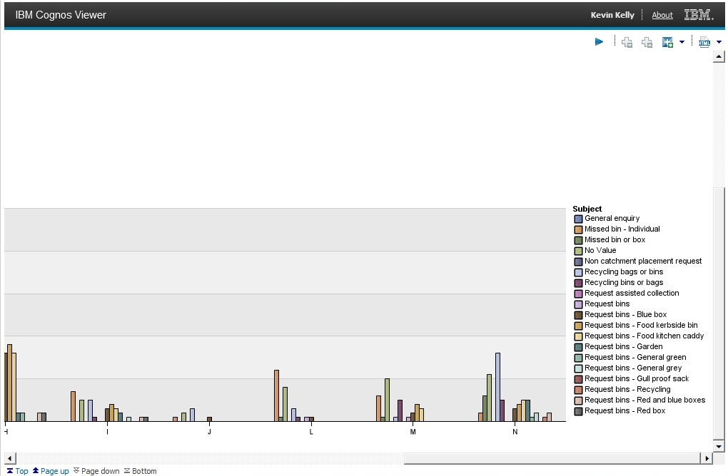

Figure second chart – group category, all subjects, entire May, zoom in to legend

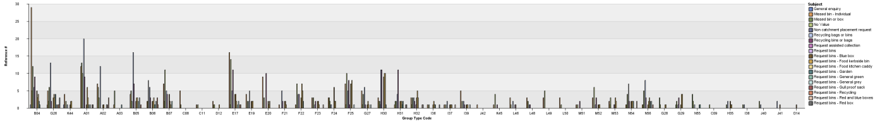

Figure 17 third chart - group code, all subjects

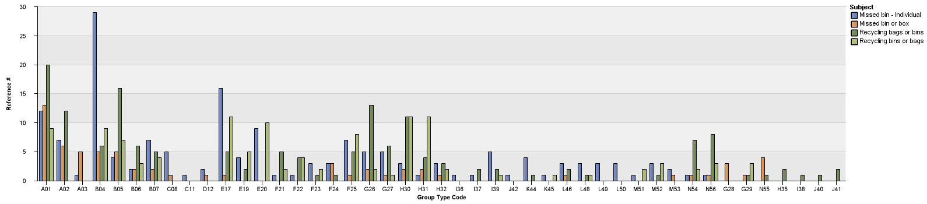

Figure fourth chart - group code, missed bins, recycling bags (4 categories)

#### Selected problems

Selected problems experienced in this phase are listed in sections below.

##### Linking problem

During the import stage where the CRM data was being added to the Mosaic package there was a problem with linking the two datasets. As a result, I was considering alternative solutions in which I would build the necessary tools.

One of the analysed solutions included setting up a server with an SQL database, populating the database with the CRM and Mosaic data and then conducting analysis using SQL and Python. The focus of the project would shift and the insights generated would be of a different level and quantity. This would decrease usefulness of the project to CEC and move the project away from the initial objective.

After a couple of failed attempts with Cognos I wanted to go through the process step by step and document the problem in as much detail as possible and move on to building the new set up. I was using Cognos documentation in the process (IBM n.d.), (IBM n.d.). Fortunately, the detailed approach adopted has led to finding a solution and the platform could be used in the project.

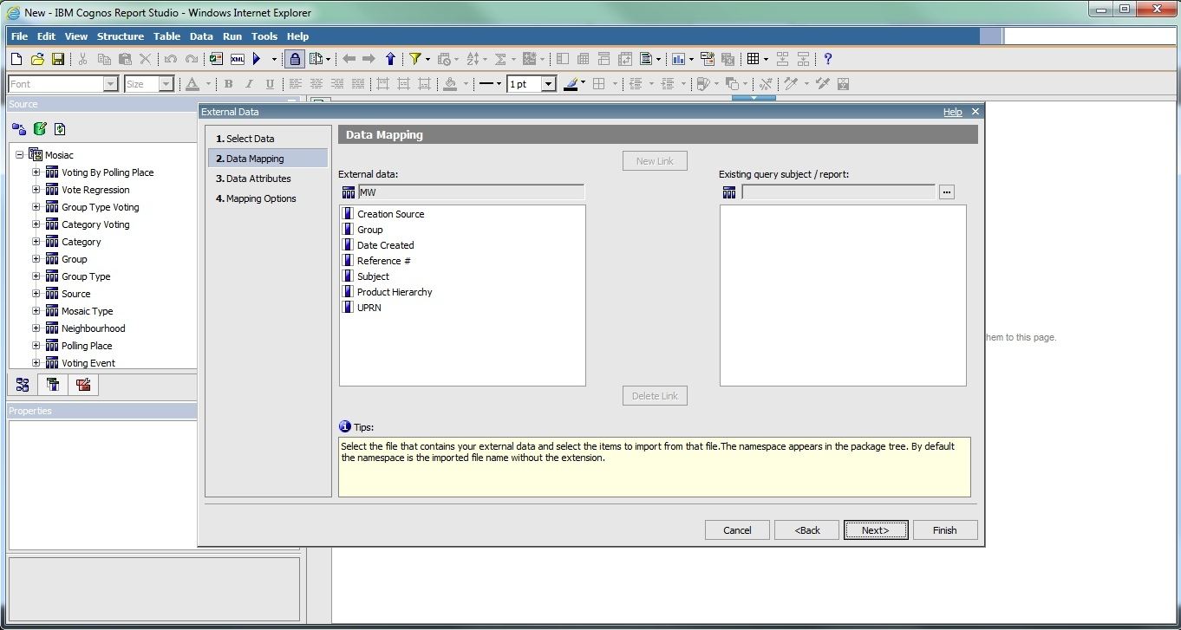

Figure Importing CRM data to Report Studio, CRM data loaded, but Mosaic data unavailable for linking

##### CRM data

One of the problems with analysing CRM data was quality of the data. There are inconsistencies in implementations across different channels. For example, entries regarding requests for recycling bins or bags reported through two different channels had different values in the “subject” field: web - "Recylcing bags or bins", phone - "Recycling bins or bags". Initially it was believed that it was an older implementation, but both values were present throughout the entire dataset suggesting both of them were in use. As a result, when analysing the data, filters had to include all possible strings related to the desired value or use a different field – “Product Hierarchy”, as was the case with the final reports.

Another problem was related to lack of documentation of the deployment of the CRM system. In the “incidents” table there are entries: “UPRN”, “second UPRN”, “UPRN 2” but they are not documented anywhere. It was difficult to reach a person who had knowledge about the system so in cases like this a “best guess” approach had to be used.

### Design of the solution

The initial reports served as a learning experience during which I became more familiar with systems and narrowed down the objectives further. I also ensured I would have the necessary access rights before making a decision to pursue this direction.

One of the decisions I had to make regarded data analysis methods. The advantage of using IBM Cognos was a very good integration of many smaller tools (e.g. ETL) and techniques (e.g. changing dimensions of analysis) which made the whole process much easier and less time consuming. As a result I would be able to conduct much more analyses that would present more value to the Council.

Selected advantages of using IBM Cognos:

* can be easily accessed by CEC employees (e.g. in their web browser)
* can be used by CEC employees in the future (they can feed my reports with other data extracts and conduct the same analysis on it)
* can be used as a starting point for future reports (they can go through my files to see how I did it, they can expand them adding or rearranging some parts of it)
* it is in line with the strategic direction of development of the Council so I would be directly contributing to the efforts of the Council
* it is within the CEC environment (no need to move my implementations to their environment)

The problem with linking datasets almost led to making a decision to drop this direction entirely and setting up an alternative environment with SQL and Python (as described in Problems section above).

In terms of ideas for analysis, I developed a list of questions I thought were relevant from perspective of someone implementing or improving transactions at the Council. I than discussed it with CEC employees (Sally Kerr and Andy Thompson), added their ideas and gave them the final word about which ones to implement. The result was a list of three questions and a decision regarding further direction.

### Design brief for the next stage

The data analysis will be conducted using IBM Cognos platform and it will use Mosaic Experian package combined with an extract of the data from the CRM system. The reports generated would not be of performance indicators nature, but will try to find data that can show behaviour of citizens manifesting in the data. They are not (primarily) intended as monitoring tools, but rather as ways of expanding perception of what is happening in service delivery. The three main questions that will be answered are listed below and they are described in detail in the following sections:

1. Cases of intentional use of multiple channels for the same issue
2. Patterns of behaviour across different channels
3. Who are the primary users of CEC services

#### Report 1 - cases of intentional use of multiple channels for the same issue

This analysis is aiming at identifying cases where citizens want to report an issue, but do not trust in it being handled the same way through different channels. The reasoning behind such behaviour is that if many tickets are opened for the same problem, one of them will “get the job done”. It will be solved the quickest possible way, because if the process behind one channel has more resources available it will be handled quicker than with the process behind another channel.

The underlying assumption is that entries in the CRM system will not be identified as related to the same problem and that time of delivery differs across different channels.

The purpose of this analysis is not to provide evidence about the assumptions being right or wrong, but to verify if such behaviour exists among receivers of the Council services.

#### Report 2 - patterns of behaviour across different channels

The purpose of this analysis is to understand patterns of behaviour of citizens across many channels.

Some of the patterns that might be revealed include:

* The user initiated a service through a channel of preferred choice (e.g. web-form). However, after not hearing from the Council for some time, the user is unsure about the status of the process and uses a channel that is considered trust worthy (e.g. face-to-face) to confirm its state.
* If the above pattern occurs only for one type of transaction it might suggest a problem with a particular service. For example, if many users try to report a missed bin over a web-form, but eventually use a phone to do it (or switch after a few uses)
* An active user who uses a particular service is trying out a digital interface, but for some reason goes back to how he access it before
* Numerical evidence for how quickly people adapt new channels (e.g. how effective an information campaign was)

#### Report 3 - who are the primary users of CEC services

Designing is a task that should be conducted with the user in mind and having an understanding of who is the primary receiver of the design helps tremendously. For this reason, designers use “personas” which make it easier to know how the user thinks or behaves. The more detailed and accurate information about the user one has, the better design decisions one can make, which results in interfaces and services that better fit the needs of people.

The questions that will be answered within this part of work are trying to increase the understanding of users receiving Council’s services. In particular, 3 user groups are recognised:

* never used CEC services
* uses CEC services occasionally (defined here as having no more than 3 interactions with CEC)
* active user of CEC services (more than 3 interactions with CEC)

The analysis is trying to identify socio-economic backgrounds that users from all 3 groups have. Because CRM data contains only data about citizens who used CEC services it will not contain information about the first group. However, by determining who is interacting with CEC one can conclude who is not using those services. In other words, social groups that do not appear in the CRM dataset can be categorized into the first group.

Some of the questions that could be answered include:

* who are primary users in general
* which social group has the most interactions within a service
* which service is most popular within a social group

## Develop

The implementation stage of the project started with three objectives coming from the previous phase. Subsequently, three reports were generated to provide analysis in those areas.

Development started in a fresh environment. CEC has provided the author with a designated work space together with a laptop and all the access rights necessary for the implementation (access from the preliminary stage was revised and a different set up was used). Due to this, the IBM Cognos package containing Mosaic Experian and CRM data had to be recreated from scratch as described in the Define phase.

The process in all three cases was to design a technical solution first and then implement it. The solution, a generated report, would consist of a number of queries that would provide analysis necessary to answer a question or an intermediate step (in more complex cases) that lead to the desired visualisations. For more information on stages in the report creation please see attached appendix containing a list of files used in the process.

### Report 1 - cases of intentional use of multiple channels for the same issue

This report is trying to provide evidence for existence of a specific type of behaviour where citizens report one and the same issue using many channels at the same time.

Proving such behaviour using solely data analysis is very difficult and should not be left only to a machine. One of the problems with this kind of analysis is that behaviour of people with different intents might manifest in the data in the exactly same way. The report might put in one category users, whose behaviour was “malicious”, but also non individual users like landlords, who visit many sites and then report a bulk of issues, residents who struggled with submitting a web-form or first time users of CEC services who were helped by a consultant in submitting a web-form.

It has to be stressed that this analysis is not trying to automatically mark people as “bad users”, but instead bring attention of a service manager to cases of unusual uses of the system. They might be pointing to a number of issues such as different delivery times across different channels, lack of trust in digital channels, low effectiveness of a channel in addressing a user need. They should be analysed and investigated further and should be treated as potential inspirations or initial influences for further improvement of service delivery.

#### Technical design

Query 1: gather all relevant data (do not include entries if channel is not specified) and add a counter for how many issues someone filed on one day

Query 2: filter results of Query 1 so that only people who reported more than one issue on one day regarding the same subject are left

Query 3: filter out from Query 2 cases with only one occurrence of such behaviour (of multiple issues regarding one subject reported on the same day)

#### Implementation

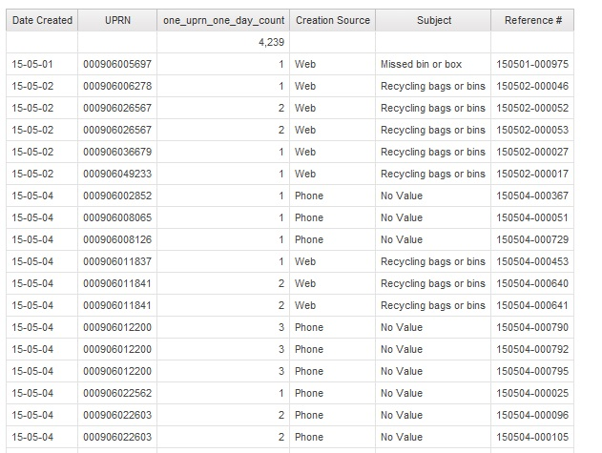

Figure Report 1, Query 1

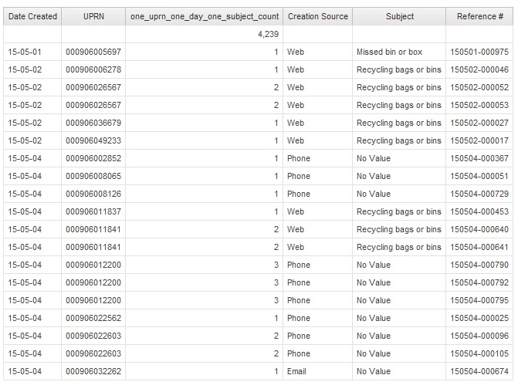

Figure Report 1, Query 2

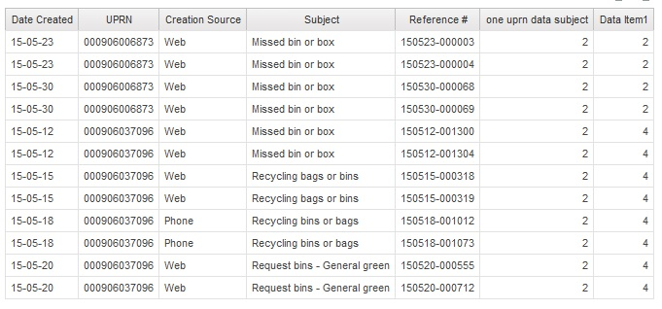

Figure Report 1, Query 3

#### Additional work

There were only two cases found of multiple cases of reporting a few times a day and none of them was unwanted behaviour. It can be speculated, that those were situations in which someone was having problems using CEC interfaces (cases of double entries with very short time distance).

Query 4 was created after conducting the above analysis. Its purpose was to provide a general overview on the number of multiple reports to give an idea of how much people struggle with an interface and how quickly they learn it.

Query 4: count number of occurrence of such behaviour (how many times did someone report the same issue more than once on the same day)

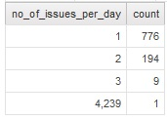

Figure Report 1, Query 4

In simple words, there were 194 people in May who on two separate occasions reported on the same subject, on the same day.

### Report 2 - patterns of behaviour across different channels

This part of analysis is trying to cast some light on behaviour of citizens across different channels.

It is based on 2 counters. The first one provides information about total number of issues reported by a citizen (“count no of issues”). The second one counts number of separate channels used to report those issues (“channels used”). Then filters are used to remove from the report cases with number of issues below 2 (“count no of issues > 1”) and number of channels used below 2 (“channels used > 1”).

In order to make the results easier to analyse, entries are grouped using UPRN – entries coming from one user are listed next to each other. Within this group, they are ordered using reference number (“Reference #”). Reference number is used instead of date of creation because there are multiple cases where there is more than 1 entry during a day. In those situations, ordering by the date does not ensure the same sequence as the sequence of creation. Reference number on the other hand, consists of 2 parts: day of creation and a serial number assigned in an ascending manner and thus the original sequence can be deducted. In the following example, both numbers were created on the same day, but the second one was created later which can be determined by the second part of the string:

150511-000837

150511-000849

The diagram below presents part of the report that was generated.

Citizen with UPRN 000906026074 submitted a “Missed bin or box” request through the web-form on 5th May and made a phone call the next day regarding a service from the same “Product Hierarchy”. Considering this is the entire activity of this user, it can be speculated, that both interactions were about the same issue. In order to verify such claim these interactions would have to be investigated further, e.g. using comments left by consultants (unstructured data (Baars & Kemper 2008)). Such additional information would be extremely useful in determining reasons for the user following up over the phone.

Citizen with UPRN 000906037096 submitted 2 queries for the same issue on 12th of May. The next day he submitted again 2 queries over the web for a different service, but what is really interesting is that after submitting them he made a phone call to the Council. This is a great example of identifying a situation where someone was not able to achieve a desired result over the web. It might have been a simple question, but clearly the person made a phone call after going through the web-form. It might be the case that this information was missing on the web-form and other users needed it as well.

#### Technical design

Query 1: count number of issues reported by a citizen, count number of channels used to report those issues, filter out number of issues below two, filter out number of channels used below two

#### Implementation

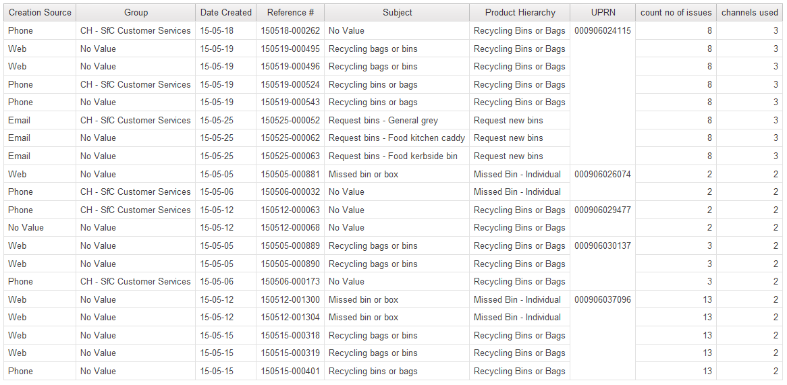

### Report 3 - who are the primary users of CEC services

This analysis starts from identifying users belonging to two categories as described in the Define phase, i.e. citizens who interacted up to three times with the Council and active users with more than three issues reported. After that a series of queries are used in order to provide insights about socio-economic background of users.

Mosaic

#### Technical design

Query 1: gather relevant data, counter with number of all interactions of a user, assign a value based on the counter identifying the category as described above (up to three, above three), assign Mosaic groups to entries

Query 2: Which services are the most popular among people in both categories? – generate a chart with services on axis x, number of entries on axis y (counted by “Reference #” field, count total aggregation) and data series for up to and below the threshold level

Query 3: Which Mosaic groups do people from both categories belong too? (which social groups use CEC services most actively) – generate a chart with Mosaic groups on axis x, number of entries on axis y (counted by “Reference #” field, count total aggregation)

Query 4: Which services are being used by different Mosaic groups? – generate a chart with Mosaic groups on axis x, number of entries on axis y (counted by “Reference #” field, count total aggregation) and data series for different services

Query 5: Which Mosaic group is the most active within a service? – first page with a value prompt, then show a chart for the selected service

#### Implementation

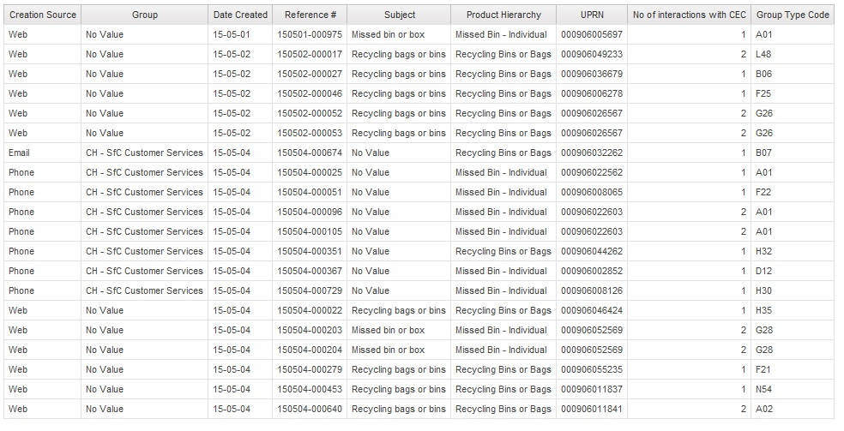

Figure Report 3, Query 1 (up to 3 interactions)

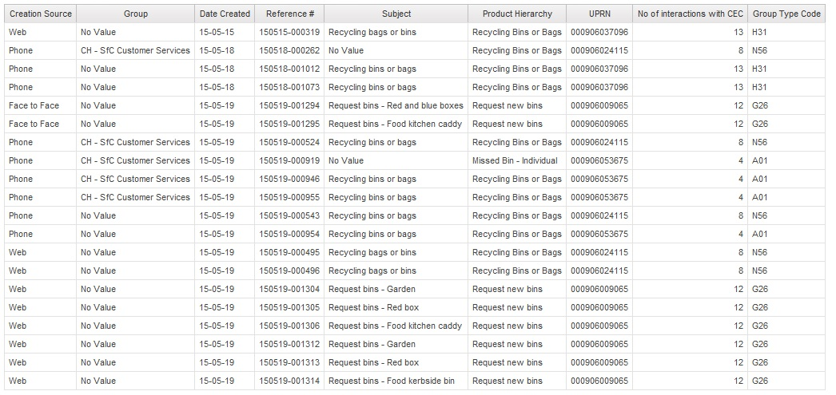

Figure Report 3, Query 1 (above 3 interactions)

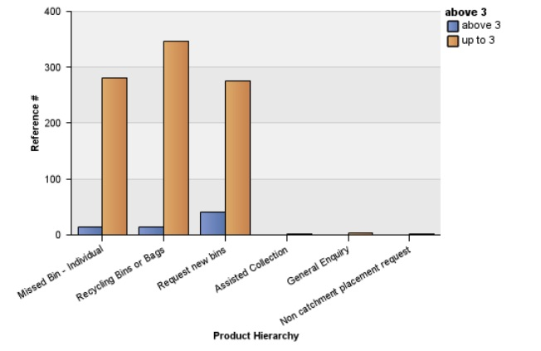

Figure Report 3, Query 2

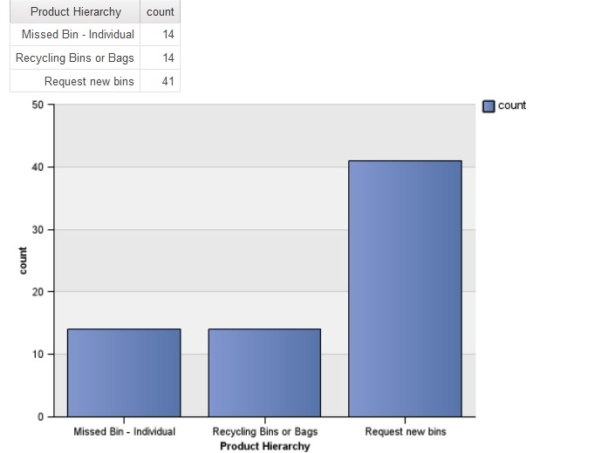

Figure Report 3, Query 2 (above three)

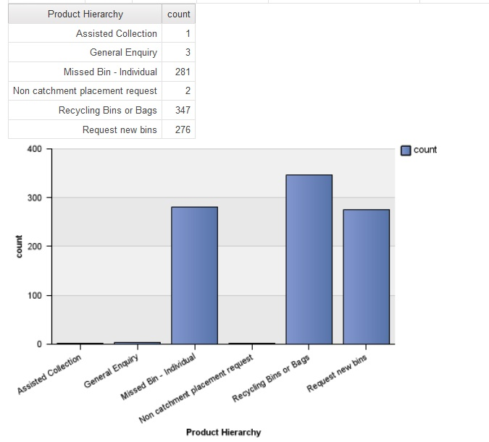

Figure Report 3, Query 2 (up to three)

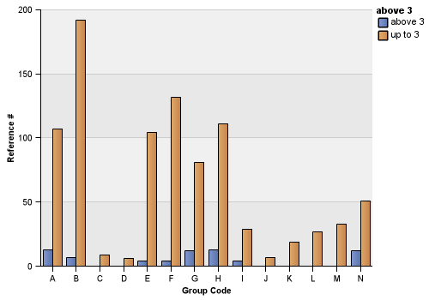

Figure Report 3, Query 3

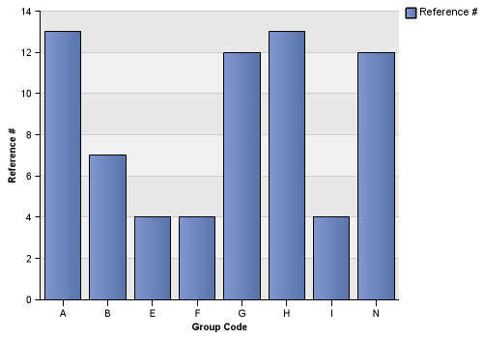

Figure Report 3, Query 3 (above three)

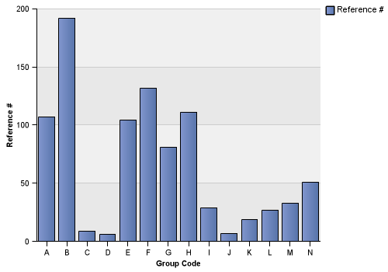

Figure Report 3, Query 3 (up to three)

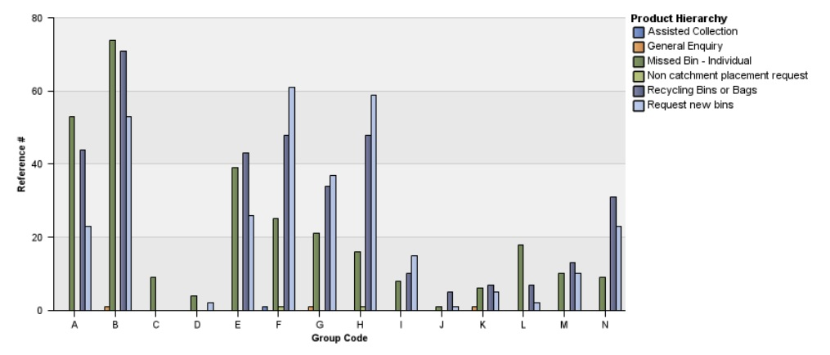

Figure Report 3, Query 4

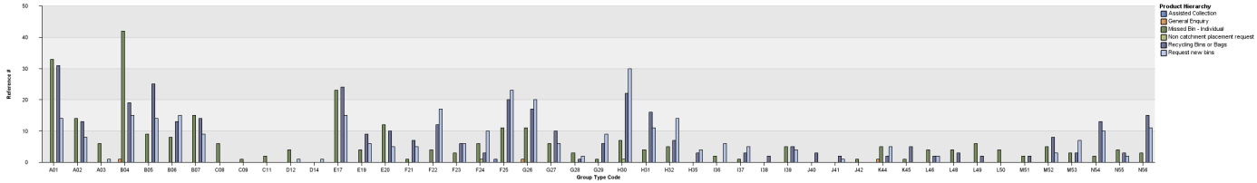

Figure Report 3, Query 4 (more granular user groups - Mosaic group and type)

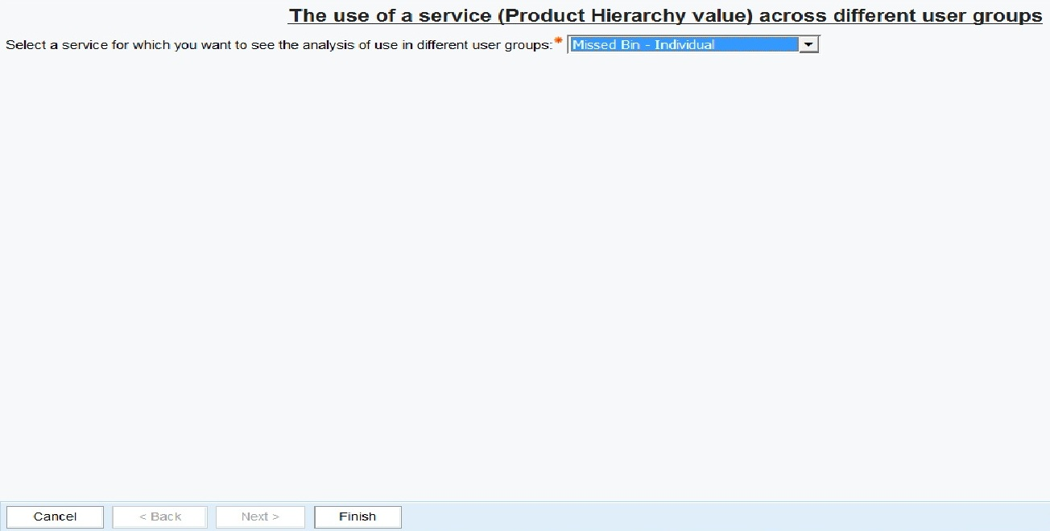

Figure Report 3, Query 5. Value prompt page with selected service - "Missed Bin - Individual"

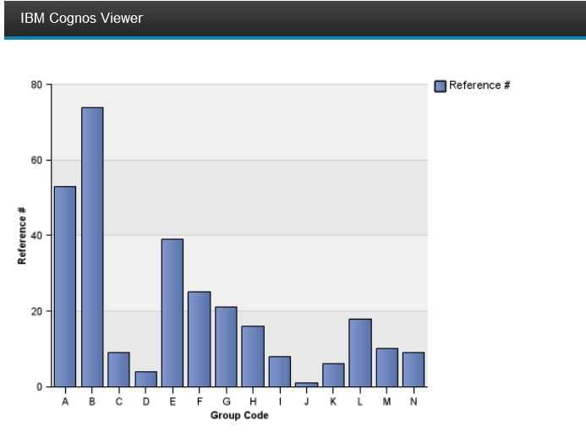

Figure Report 3, Query 5

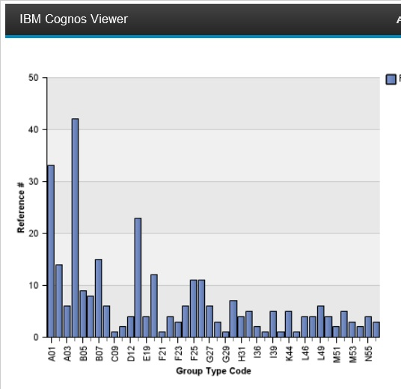

Figure Report 3, Query 5. (more granular user groups - Mosaic group and type)

## Deliver

### Presentation at the Council (evaluation)

Give and describe a presentation in the Council, quote reactions

The reports can be run on any data set, I used extract from May, but it’s just a matter of pointing to a different file

* Marketing people would be interested in global overview of services

## Problems and conclusions

* It would help the project if a more official relationship was established between the University of Edinburgh and the City of Edinburgh Council. If the project had an agreed starting time a temporary pass to the building could have been prepared. A general scope might have helped in finding a business owner of the project (e.g. Business Intelligence and Digital Service) and getting access to the licensed platforms would happen within existing structures. The fact that the project had an open nature at the beginning was a very important part of it and helped in achieving a natural convergence between different departments and making the outcomes relevant and useful to the Council. Allocating even a small amount of resources (time of people involved) by senior management would help the project by not putting the burden of excessive time on CEC employees.
* Not having a work station (I could only work using a spare workstation, with extremely limited network disk space and that was when someone from BI was present, e.g. I had to arrive in the morning when they did, leave when they did).
* Not enough space on the network drive to save files (I was always using somebody else’s credentials).
* In Report 1, Query 3, in the results you can see that on 05-15 and 05-18 someone contacted CEC probably regarding the same issue. However, they used different channels and values in field subject are different. This is probably due to inconsistencies in implementations between web and phone channel. This has an impact on the quality of data. It is recommended to either use a different field for identifying subject of the request (e.g. “Product Hierarchy”) or fix this bug.
* The “incidents” table in the CRM system contains only information about transactions initiated by citizens, e.g. they submitted a web-form. It would be very useful to combine this data with web analytics to widen the analysis and add cases where the form was not submitted, e.g. someone started filling the form, but for some reason did not submit it or made a phone call to the Council instead.
* The “incidents” table in the CRM system provides a lot of data for analysis, but is not sufficient to understand fully the situation around an interaction between a resident and the CEC. It would be extremely useful to combine it with analysis of unstructured data, e.g. comments left by consultants interacting with citizens.
* The “incidents” table in the CRM system does not contain a field that allows identification of all entries related to one problem. Up to author’s best knowledge there is no mechanism at the moment to link multiple incidents entries regarding the same problem, e.g. many people reporting the same bin as missed.
* Difficulties creating charts using calculated fields (no problems using values from a database). Charts do not work with automated aggregation function, you have to use “none” as the aggregation function

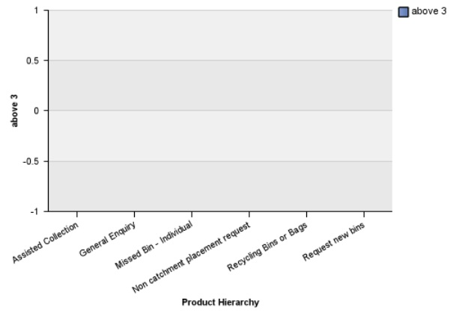

Figure Report 3, Query 2. Aggregation function not set to "none"

* The CRM data source file had blank entries. IBM Cognos considered them valid (did not filter them out). They were showing up in the all analyses as empty and could not be filtered out. There was about 4200 of them.

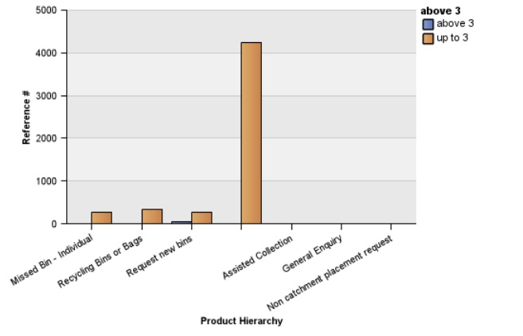

Figure Report 3, Query 2. Empty entries showing up in all analyses

* when setting filter (Data Item1 > 2) I got a result (but when started the entire report from scratch it's working properly):

- when I work on a query and put a filter on data, generate report, save file, everything works fine. Then I use the same file to work on another report and start from removing the filter - when I run the report then the dates are still filtered.

1. In many cases there was no knowledge of what was done a few months ago (e.g. “there are some profiles in the Council” – it turns out those were Mosaic profiles)

# Analysis or Evaluation

These reports should be treated as part of a bigger “transformation” project. Identifying cases where users struggled with a web interface by CRM data analysis should be one of many ways of improving service used together with for example focus groups.

discuss the extent to which the develop and deliver phases fulfilled the goals of the design phase? It’s good to be able to say that you had measurable objectives, and then assess the extent to which you achieved them.

## Evaluation of the tools used

CRM data:

* A lot of entries are there just to keep a track of what’s happening. It’s better to have something than nothing, but majority of entries cannot be used for an analysis as detailed as this
* Would be extremely useful to couple it with unstructured data
* what's the difference between 'subject' and 'product hierarchy'?
* Would be extremely useful to get access to any documentation, talk to someone knowledgeable about the system
  + UPRN vs UCRN vs USRN

- I couldn't speak to someone knowledgable about the CRM system. As a result I couldn't determine things about the CRM dataset, e.g. difference between 'subject' and 'Product Hierarchy'

* Not knowing (and not knowing who knows) the structure of the database in CRM system

IBM Cognos:

* A lot of information available – the tool has been around for a long time, there is a lot of documentation online, many books about it (MIT n.d.)
* Quite easy way of exporting data
* Many small bugs
* it takes a while to learn it – many things are not intuitive and you just have to learn “the cognos way”

Useful things about working with Cognos:

* Deals well with ETL (Extract, Transform, Load) activities, e.g. exporting data from many formats, the initial processing stage of integrating data
* Allows to create reports using both relational and dimensional data (combined in one report)
* If you change a field in one place it automatically gets updated elsewhere in the report.

## Evaluation of work undertaken

Describe what would be the next step, what else I could have done, but didn’t have time/resources to do

* How to improve charts:
  + Add title
  + Add values on columns on the chart
  + Add drill through (new report opens when you click on a column, pass parameter)

CRM:

* If there were more resources available (time) it could have been investigated further
* , if I had more time I might have be more selective about the incidents table

### Report 1

### Report 2

In report 2, the analysis would benefit a lot from using unstructured data. In many cases, analysis as conducted here will not provide definitive answers, but will pinpoint areas that can be improved: cases where citizens are struggling, not trusting. The information provided is very detailed, e.g. it will not only show that residents were struggling with a particular interface, it will also show whether all of them struggled or only a specific part of users. This can be then used to improve the design with very specific personas in mind.

In report 2, it is very difficult

- different values in the field subject depending on the channel (e.g. report 2)

It would be very useful to throw into Cognos more data sets:

* web analytics - It misses cases where someone wanted to report an issue, but in the end didn’t – struggled and failed. After that they went to another channel (e.g. phone), but the initial attempt was not registered in the CRM system.
* Unstructured data – probably exists in the CRM data, but in a different table. I used incidents, but there are dozens others
* Create capability to store unstructured data in the CRM system if it’s not there yet
* Stress to consultants to put as much information as possible, make a workshop for them
* Putting procedures in place that would improve the design of a web-form/service based on such case studies would increase Council’s capacity for improvement and learning.

### Report 3

## Evaluation of methodology used

Double diamond, my first stage was exploratory, it’s more like real life project, more flexibility in adapting to what would be useful to the council,

Requires a tremendous amount of persistence

The more people are open and willing to help the better it will work. If there is no will on the side of clients it will completely collapse, won’t move anything a tiniest bit.

The better understanding the clients have of their own infrastructure the better it will work. If there is little knowledge, it will not produce relevant results. Simply because designers will not “hit the ground” and will produce a solution that is “floating” just like theirs understanding. The key, the fundamental enabler is a very thorough understanding of the whole picture. It would be a great material for a bigger research project (systems engineering/IT management) – to understand the infrastructure at the Council and the strategy they have for transformation. The results could be published in the Council (or even a knowledge base could be build that would be maintained by the employees afterwards) so that everyone have access to it. Corporate architects (like Neil) would be the first point of contact for such project.

# Conclusion

* you can go very deep with those analysis, e.g. I started with the goal to identify malicious uses of multiple channels, I generated 3 reports, I realized I could do a few more looking for how people learn different channels -> the rate at which people file multiple times within one channel goes down with time (they learn)
* There are many open questions and potential for further study
* The timescale of the project was extremely short given its complexity. Many parts of the project could easily take months to be properly developed. However, it was not aiming at delivering a fully-fledged product. Instead, the objective was to look at the design process in its entirety and as a result in many cases compromises had to be reached.
* Adopt a more “conscious” approach in terms of choosing design tools at each stage, i.e. I didn’t sit down and think what would be the best method to understand user needs.

# Appendix A – list of files created during the project

Files created up to Development Phase:

• “MW v0.1 self” - file to learn Cognos, shows how to combine CRM data with Mosaic data

• “MW v0.1 self2” - first attempt to create a chart, doesn't work

• “MW v0.1 self3” - attempt to create a chart, the query itself is working (everything is correct from the sytax point of view), but data is unavailable (aggregate function? filtering error?)

• “MW v0.1 self4” - debugging the self3 report, added a list to show filtered data returned from the query. Result: there are some entries after filtering, but not as expected

• “MW v0.1 self5” - from the start, this time the results are as expected (type of result, number of result)

• “MW v0.2, working chart, 3 days, type of report – day” - first chart working as expected, it shows numbers about queries from all services grouped into Mosaic groups, counted by reference, limited to 3 days (x - mosaic group, e.g. B, G, K; y - count by reference, multiple columns - different values in 'subject')

• “MW v0.2, working chart, entire May (previous was 4 days), Mosaic group – subject” - second chart working as expected, more accurate; x - type code, e.g. A01, A02; y - count by reference; only 4 services - 4 columns; for the entire May

• “MW v0.2, working chart, entire May, Mosaic group – subject” - similar to previous one, not as detailed, x - Mosaic groups, e.g. B, G; y - count by reference; columns - different services (different values in 'subject'); entire May

Files created during the Development phase:

• “one issue on multiple channels v1.0” - find cases of misuse of multiple channels

• “MW report 3”, “MW Report 3, blank chart” - base report that can be used to generate different reports about number of interactions with the Council, couldn't overwrite the original one, created another one to have a more meaningful name

• “MW report 3, chart 1” - both above and below 3 interactions on one chart

• “MW report 3, chart 1.1 blank” - template for the charts 1.1 and 1.2

• “MW report 3, chart 1.1” - chart with only above 3 interactions, using filter

• “MW report 3, chart 1.1 correct” - chart with only above 3 iteractions, using filter and a list to show data (identical to the previous one, extended with the list, couldn't overwrite the previous one)

• “MW report 3, chart 1.2 correct” - chart with only below 3 interactions, with list

the last 3 charts did not have axis sorted, I figured out how to sort axis starting from chart 3.2

further parts of report 3 has 2 dimensions which have many entries. As a result it would have a lot of columns and would not be easily readible. So I decided to split it into 3 charts: groups x services; detailed groups x services; selectable service -> group

• “MW report 3, chart 2.1” - Mosaic group x services

• “MW report 3, chart 2.2” - Mosaic group detailed x services

• “MW report 3, chart 2.3 group code” - the use of the selected service across different Mosaic groups

• “MW report 3, chart 2.3 group type code” - the use of the selected service across different Mosaic detailed groups

• “MW report 3, chart 3.1” - blank report that is used as a basis for the other 3.1 reports

• “MW report 3, chart 3.1 above 3” - Mosaic groups that active users belong to

• “MW report 3, chart 3.1 up to 3” - Mosaic groups that occassional users belong to

• “report 3.1 “- 3 charts on one page

working 27.07

• “MW Report 2, 2.1” – identify citizens who interacted multiple times

• “MW Report 2, 2.2” – multiple interactions through different channels

Recommendations for further analysis after 2.2: analyze the issues, what happened there, comments, any unstructured data around this issue that is available in the system, closed times and dates, when this person interacts with the council again ask them questions what was the problem.

The result might be that only people with multiple issues will be contacted, this does not have to be the case. It should be compared with no feedback at all and in this case you can identify people who could provide feedback with very high accurracy. As a counterbalance, the questions might be asked to people from the same social group.

Analyze a few examples:

• Someone starts on the web, the next day they call

• Someone start with face-to-face, then they open a number of tickets on the same issue through web the next day

# Appendix B

List of all people I spoke with:

* + Sally Kerr
  + Neil Dumbleton (Corporate Architect, first meeting)
  + Jana Ramos (Digital Services, works closely with Sally, Sally introduced me)
  + Catherine Macrae (“leading on CX for our Council Channel Shift project”, Sally introduced me to her)
  + Neil? Database administrator?
  + Gosia Szymczak (Sally introduced me to Gosia)
  + Kevin Kelly (after meeting Gosia, she introduced me to Kevin)
  + Andy Thomson (at some point, Sally introduced me to Andy
  + Angela McInnes (Kevin introduced me to Angela)
  + Emilio G. Zamudio (the other student at CEC, Andy introduced me to the fellow student)
  + A gentleman conducting user studies (Andy introduced me to him)
  + Iain Elder, MSc student who completed a degree just before me. He was also doing a dissertation on BI (Ewan introduced me to him)
  + Chris Jeffery (Andy forwarded an e-mail with my question to him, he was the CRM expert answering my questions, Andy cc-ed me to an e-mail)

# Bibliography

Baars, H. & Kemper, H.-G., 2008. Management Support with Structured and Unstructured Data—An Integrated Business Intelligence Framework. *Information Systems Management*, 25(2), pp.132–148.

Bevan, N., 2001. International standards for HCI and usability. *International Journal of Human-Computer Studies*, 55(4), pp.1–18.

Browne, D., 2010. Front cover IBM Cognos Business Intelligence V10 . 1. *Red Books*, REDP-4693-, p.26.

Browne, D. et al., 2010. *IBM Cognos Business Intelligence V10. 1 Handbook*, IBM Redbooks.

Chan, K.W. & Mauborgne, R., 2005. Blue ocean strategy: from theory to practice. *California management review*, 47(3), pp.105–121.

Council, D., 2007. Eleven Lessons: Managing Design in Eleven Global Brands. A Study of the Design Process. *London: Design Council, www. designcouncil. org. uk/sites/default/files/asset/document/ElevenLessons_Design_Council*, 20(282), p.29.

Council, D., 2005. The “double diamond”design process model. *Design Council*. Available at: http://www.designcouncil.org.uk/news-opinion/design-process-what-double-diamond.

Demchenko, Y., De Laat, C. & Membrey, P., 2014. Defining architecture components of the Big Data Ecosystem. In *Collaboration Technologies and Systems (CTS), 2014 International Conference on*. pp. 104–112.

DIS, I.S.O., 2009. 9241-210: 2010. Ergonomics of human system interaction-Part 210: Human-centred design for interactive systems. *International Standardization Organization (ISO). Switzerland*.

Douglas, L., 2001. 3d data management: Controlling data volume, velocity and variety. *Gartner. Retrieved*, 6.

Earthy, J., Jones, B.S. & Bevan, N., 2001. The improvement of human-centred processes—facing the challenge and reaping the benefit of ISO 13407. *International Journal of Human-Computer Studies*, 55(4), pp.553–585. Available at: http://linkinghub.elsevier.com/retrieve/pii/S1071581901904938\nhttp://dx.doi.org/10.1006/ijhc.2001.0493.

Experian, 2014. Mosaic data methodology and build. Available at: http://www.experian.co.uk/assets/marketing-services/presentations/mosaic-data-methodology-and-build.pdf [Accessed August 7, 2015].

Finance and Resources Committee, 2016. Finance and Resources Committee ICT Services and Transformation Procurement – Final Stage Report. , (August 2015), pp.1–18.

Gasson, S., 2003. Human-Centered vs. User-Centered Approaches to Information System Design. *Journal of Information Technology Theory and Application*, 5(2), pp.29–46.

Gill, K.S., 1996. The foundations of human-centred systems. In *Human machine symbiosis*. Springer, pp. 1–68.

Greenbaum, J., 1993. A design of one’s own: towards participatory design in the United States. *Participatory design: Principles and practices*, pp.27–37.

Gulliksen, J. et al., 2003. Key principles for user-centred systems design. *Behaviour & Information Technology*, 22(6), pp.397–409.

IBM, 2015. IBM Business analytics. Available at: http://www-03.ibm.com/software/products/en/category/business-analytics [Accessed July 9, 2015].

IBM, IBM Knowledge Centre - Manage External Data. Available at: https://www-304.ibm.com/support/knowledgecenter/SSEP7J_10.2.2/com.ibm.swg.ba.cognos.ug_cr_rptstd.10.2.2.doc/c_rs_cwa_mng_ext_dta.html [Accessed August 3, 2015a].

IBM, IBM Knowledge Centre - Map Data. Available at: https://www-304.ibm.com/support/knowledgecenter/SSEP7J_10.2.2/com.ibm.swg.ba.cognos.ug_cr_rptstd.10.2.2.doc/t_id_rs_persdat_161mapdata.html%23id_rs_persdat_161MapData [Accessed August 3, 2015b].

IBM, IBM Knowledge Centre - Preparing to Work with your External Data. Available at: https://www-304.ibm.com/support/knowledgecenter/#!/SSEP7J_10.2.2/com.ibm.swg.ba.cognos.ug_cr_rptstd.10.2.2.doc/c_prep_ext_data.html%23prep_ext_data [Accessed August 7, 2015c].

ISO, I., 1999. 13407: Human-centred design processes for interactive systems. *Geneva: ISO*.

Kurosu, M., 2011. *Human centered design*, Springer.

Liem, A. & Sanders, E.B.N., 2011. The impact of human-centred design workshops in strategic design projects. *Lecture Notes in Computer Science (including subseries Lecture Notes in Artificial Intelligence and Lecture Notes in Bioinformatics)*, 6776 LNCS, pp.110–119.

Maguire, M., 2001. Methods to support human-centred design. *International Journal of Human-Computer Studies*, 55(4), pp.587–634. Available at: http://www.sciencedirect.com/science/article/pii/S1071581901905038\nhttp://ac.els-cdn.com/S1071581901905038/1-s2.0-S1071581901905038-main.pdf?_tid=f8ea644e-69f8-11e2-9f7c-00000aab0f6b&acdnat=1359453062_0364809ffb4966275f7843c58d4b4082.

McAfee, A. & Brynjolfsson, E., 2012. Big Data. The management revolution. *Harvard Buiness Review*, 90(10), pp.61–68. Available at: http://www.buyukverienstitusu.com/s/1870/i/Big_Data_2.pdf.

Minelli, M., Chambers, M. & Dhiraj, A., 2012. *Big data, big analytics: emerging business intelligence and analytic trends for today’s businesses*, John Wiley & Sons.

MIT, Knowledge Base - search results for “Cognos Report Studio.” Available at: http://kb.mit.edu/confluence/dosearchsite.action?key=conf_global&searchQuery.queryString=cognos+report+studio&searchQuery.spaceKey=conf_global.

Nickerson, R.S., 1969. Man-computer interaction: A challenge for human factors research. *Ergonomics*, 12(4), pp.501–517.

NIST, 2015. NIST Big Data Working Group (NBD-WG). Available at: http://bigdatawg.nist.gov/home.php [Accessed July 10, 2015].

Norman, D., 1988. The Design of Everyday Things (Originally published: The psychology of everyday things). *The Design of Everyday Things (Originally published: The psychology of everyday things)*.

Norman, D.A., 2013. *The design of everyday things: Revised and expanded edition*, Basic books.

Norman, D.A. & Draper, S.W., 1986. User centered system design.

Prahalad, C. & Ramaswamy, V., 2000. Co-opting customer competence. *Harvard business review*, pp.1–8. Available at: http://www.sld.cu/galerias/pdf/sitios/infodir/coopting_customer_competence.pdf.

Ritter, F.E., Baxter, G.D. & Churchill, E.F., 2014. *Foundations for Designing User-Centered Systems*, Springer.

Robert, B., 1965. The New utopians: A Study of Systems Design and Social Change. *Englewood Cliffs*, pp.47–49.

Verganti, R., 2013. *Design driven innovation: changing the rules of competition by radically innovating what things mean*, Harvard Business Press.

Ward, J.S. & Barker, A., 2013. Undefined By Data: A Survey of Big Data Definitions. *arXiv.org*. Available at: http://arxiv.org/abs/1309.5821\npapers3://publication/uuid/63831F5F-B214-46D5-8A86-671042BE993F.